Pennsylvania Surgical News
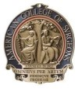

News & Updates for the Keystone and Metropolitan Philadelphia Chapters
American College of Surgeons
March 2021

Spring has sprung! The weather is getting sunny and warm and daylight savings times in now in effect. Hopefully, we will be able to begin moving outdoors and finding ways to chase away the winter blues.

Dr. Shannon Marie Foster, President of the Keystone Chapter shares another insightful article in this month’s Meanderings of A Wandering Surgeon. Check out her column on page 2.

The ACS and PA Chapters continue to watch new and moving legislation. Of particular note was the re-introduction of Prior Authorization legislation in mid-March (previously SB 920). Senator Kristen Phillips-Hills’ (R-York Co) bill intent is to improve transparency, accessibility and consistent application of prior authorization by including a standard definition. It will also significantly streamline the process by requiring insurers to make available an electronic communications network that permits prior authorization requests to be submitted electronically, and authorizations and adverse determinations to likewise be returned electronically. (SB 225 – Sen. Phillips-Hill).
The Senator’s memorandum also notes that transparency and consistent application of prior authorization criteria and clinical expectations will be enhanced by requiring the disclosure of prior authorization requirements, restrictions and/or amendments to subscribers and physicians. Improved patient care will result from requiring consistent response times and processes with respect to prior authorizations, adverse determinations, and appeal procedures, including external review. And practice efficiency will be improved by establishing limitations on routine medical record requests by insurers.
A key element of this year’s bill will be the development of a standard prior authorization form that can be electronically submitted by all health care providers and accepted by all health insurers.

We will keep you updated on its progression and issue an Action Alert at the appropriate time.

ACS Leadership & Advocacy Summit kicks off virtually in May. Additional details can be found on page 4.

Still time to remit your 2021 membership dues! Your financial support helps the chapters continue to focus on representing you and the surgical community through educational programs, legislative advocacy, and networking opportunities. If you have misplaced your renewal invoice, contact your Chapter office (info@kc-acs.org or info@mp-acs.org). Dues can be easily remitted online using a credit or debit card.

Updates on the March 16th Fellowship 101 webinar and the upcoming Keystone Chapter Case Review Competition can be found starting on Page 3.
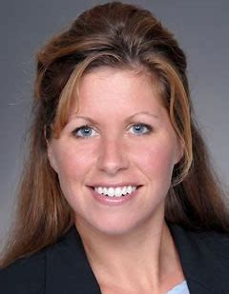
Meanderings from A Wandering Surgeon

Shannon Marie Foster, MD, FACS
Keystone Chapter President

Greetings friends and colleagues – The last throes of winter and spring is upon us 😊.

Do you find that there are moments that are best eliminated? Here is a recent sample:

Setting: Normal day, ninja rounds (slipping about without any accompaniment due to limited time). Knock on door. Enter patient room of a 60 something white male whom you have visited multiple times previously – “morning Mr. Soandso it’s Dr. Foster”. “Hi Shannon”. Brief interaction and exam per routine, during which the bedding and side table is adjusted “thanks, sweetie” and then as closing “honey, can you get me some fresh ice?” “Ok, Mr. Soandso, I’ll be right back”. Just so happens the nutrition room (kitchenette) is only across the hall, hence able to grab and quickly return. He thanks and asks, “when is Dr. Thusandsuch (my partner) coming to see me?” “Tomorrow he’s the rounder” but as I walk to the door, I seem to be pulled back around to ask “Mr. Soandso, why is it that you call my partners dr and me by my first name?” He shares a big toothy grin “cause that’s what I think is best”…pause…”and appropriate”. The look between us was long and awkward, him intense and me recoiling - I felt it best to not engage any further and walked out. What to name it? Microaggression seems an understatement. And whether or not you want to believe it – moments like that are not infrequent – less frequent than when I started in this business, but still regular occurrences. Doesn’t make me feel very good. Kind of yuck actually.

Or this one:

Setting: Grocery shopping.
Stooping and squatting in the bulk food isles to select sunflower seeds.

From the left: A middle-aged woman and her two teenie type children – none wearing masks.

From the right: A middle-aged man – not wearing a mask.

Both keep edging closer to my space – eventually encroaching from each side over my head – having a joyful conversation about food, the weather and their gratitude for each other – him to her “thank you for not wearing a mask” – she back to him “no, thank you SOOOO much for not wearing a mask” – me reaching my limit and standing up (literally) and to both of them “no one else here today thanks either one of you for not wearing masks”. Not surprisingly, both made multiple comments – including telling me to mind my business, stay home, and other ruder and more explicit unkindnesses which are not worthy of repeating. She walks away with the tweens; he then proceeds to follow me around the produce section speaking of the wonders of oregano for the immune system and the fake reports inflating the impact of the virus. Thankfully, my husband returned from his simple foray of weighing the fruit, and the unmasked man walked away. Hmmm. Was there a good way to handle this? Best would have been if it never happened. I was annoyed that they were having this bonding moment of rule breaking (masks are required are they not?) over my head, the discourteousness knew no bounds, so I said something. Following me around the store – what do we call that? Macro threat? Really yuck.

In both of these moments – the intersection of my truth and their truth was never going to be without a crash – so it is better to just avoid the collision? Damage always needs inspected and repaired. I work a bit on mine every day.
Shannon Marie Foster, MD, FACS, President of the Keystone Chapter. She also serves at the national level as a Governor-At-Large, Vice-Chair of Communications Pillar Outreach Group, liaison to both the Women in Surgery (WiS) and Trauma (CoT) Committees.

Keystone Chapter Case Review in Surgery Competition

The Case Review submission deadline has ended for the Keystone Chapter’s Case Review in Surgery competition. Submissions are now in the review/judging stage. Once the judges have scored each submission, notifications will be sent, and the top submissions will present their Case Review in a live, virtual format the week of April 26th.

Winning submissions will be eligible and submitted for publication consideration in the national and renown, now open-source ACS Case Reviews in Surgery.

Case Reviews in Surgery is an interesting, unique, peer-reviewed program addressing some of the most significant educational needs of practicing surgeons and surgery residents. The published case reviews will offer our members and the surgical community access to high-quality, in-depth analyses of actual surgical cases.

Watch for the upcoming announcement and details on participating in the Case Review Webinar.

Good luck to all our Case Review submitters!

Metropolitan Philadelphia Chapter
Fellowship 101 Webinar

The Metro Philly Chapter hosted its first Fellowship 101 webinar on March 16th. Over 190 participants registered for the 90-minute session geared for residents and medical students who are facing the next step in their surgical career, selecting a Fellowship program.

The event consisted of a keynote overview of fellowship programs, things to consider, and other helpful information. Alison Powers provided a brief update on the ACS and resources available through the RAS specialty group. Participants were then able to move into fifteen different breakout rooms, each focused on a specific surgical fellowship program.

Faculty, program directors, and other specialty surgeons from the many Philadelphia-based institutions were available in each room to provide details and answers questions on their specific specialty program.

Initial feedback from our residents and medical students was positive and the Chapter plans to make this a recurring program for our members.

MPACS would like to take this opportunity to recognize and thank our Premier and Event Sponsors. Without the support of these organizations, programs like the Fellowship 101 webinar would not be possible.

Premier Sponsor:
Event Sponsors:

American College of Surgeons News & Updates

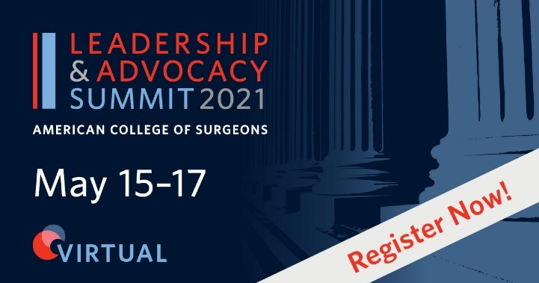

The ACS 2021 Leadership & Advocacy Summit will be held virtually, May 15-17th. The dual meeting offers comprehensive and specialized sessions to provide ACS members, leaders, and advocates with topics focused on effective surgeon leadership, as well as updates on advocacy and a virtual Congressional visit to your legislator’s office. Registration is now open.

The Leadership Summit, held on Saturday, May 15th, offers compelling speakers addressing key topics in surgical leadership. Featured topics this year include:
- Implementing impactful ideas in care delivery
- Empowering early-career surgeons to reach their full potential
- Improving patient outcomes and fostering innovation through team diversity
- Helping your team manage moral injury through COVID-19 and beyond
- Stumbling into authentic leadership
- Cultivating high-performing teams
- ACS Chapter Success Stories

The Leadership Summit is open to all ACS members and non-members.

The Advocacy Summit kicks off Sunday, May 16th and will highlight legislative priorities the College is pursuing on your behalf. The session will assist members to develop their advocacy skills learn about legislative and health policy priorities and participate in a virtual advocacy meeting with members of Congress and their staffs.

The program on May 16th is open to all ACS members and non-members. Only active ACS members and Chapter Administrators are eligible to attend the virtual congressional visits on Monday, May 17th.

For additional information, visit the ACS website.

REGISTER TODAY

Legislative Bill Activity in PA

ACS and your local Chapters continue to monitor legislative activity both on the Federal and State level. The new legislative session has begun, and we are currently monitoring 21 state bills.

[CLICK HERE] to view the complete list of all Federal and State legislation being monitored across the country by ACS.

Even though in-person visits continue to be restricted, an introductory phone call or email to your legislator (especially newly appointed) opens the door for a discussion on healthcare issues. Most legislators admit they have limited experience with healthcare issues. Having an expert to connect with when they have questions is critical to making sure you, your practice, and your patients are well represented. Not sure who your representative is? Click Here and use the “Find Your Legislator” search.

Women in Surgery
Committee
Virtual
Leadership Seminar
April 24, 2021

ACS Women in Surgery Committee Virtual Leadership Seminar is scheduled for Saturday, April 24th from 10:00 AM to 1:00 PM (Eastern).

Learning to grow and enhance one’s skills as a leader is important throughout every stage of your career as a surgeon and in your professional and personal endeavors. Join the ACS WIS for guidance on this important topic.

Sessions include:
- Unique Career Challenges Facing Women Surgeons (Mary Hawn, MD, FACS)
- Diversity & Inclusion: The Way Forward (Fatima Cody Stanford, MD, MPH, MA, FAAP, FACP, FAHA, FTOS)
- Leadership in the American College of Surgeons (Beth Sutton, MD, FACS)

REGISTER TODAY

For additional information on the Women in Surgery Committee, visit ACS WIS.

ACS RESOURCES

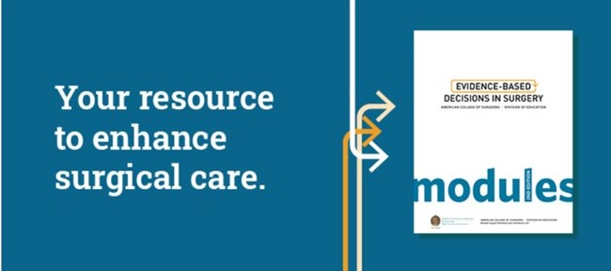

Evidence-Based Decisions in Surgery (EBDS)
Making Practice Guidelines Accessible

Evidence-Based Decisions in Surgery (EBDS) helps you improve surgical quality through quick, easy-to-follow modules that make guideline-based practices less cumbersome.

EBDS includes point-of-care modules for the top 20 most common general surgical procedures. Each module in EBDS is based on evidence that helps you quickly understand a practice guideline. Instead of going through the 100-250 pages of most practice guidelines, EBDS takes you through step-by-step modules, helping you put the content into practice more easily.

ACS MEMBERS: VIEW THE MODULES

Now available as a convenient digital book, EBDS features updated modules as new guidelines become available. If you ever have trouble with your WiFi connection in your hospital, this new format will be accessible by your side whenever you need it. The updated EBDS Digital Book is available for $100. Get your copy today!

PURCHASE

To view all resources available to ACS members, visit the ACS Educational Resources Page.

RESOURCES

A New Robotic Surgery Is Giving Patients With a Rare Condition a Second Chance at Life

Charles Bakhos, MD, MS, FACS

Temple University Hospital

Imagine if every time you took a breath, your airway almost completely collapsed. For patients suffering from an elusive condition called tracheobronchomalacis (TBM), this sensation of struggling to breathe can not only feel frightening but make exercising coughing, or even laughing incredibly difficult. Even more seriously, many people struggle with it without knowing why or receiving the correct treatment as it’s considerably underdiagnosed.
“If you were to look carefully in patients who have respiratory symptoms and other conditions, you would probably find TBM in at least 10–20% of them,” says Charles T. Bakhos, MD, MS, FACS, a Temple thoracic surgeon specializing in diseases of the airway.

At the Temple Lung Center, he and his colleagues are using new, innovative treatments to help more people suffering from TBM. The center now stands apart in its field.

People from across the U.S. are seeking out Temple for TBM. For Danielle Hong, this condition had long prevented her from getting through her workday, cleaning her house, or even walking her dog without feeling short of breath. The New Jersey resident went through a series of hospitalizations and referrals before finally receiving TBM as a potential diagnosis.
Her local pulmonologist advised her the Temple Lung Center was “the place to go” for expert TBM care from Dr. Bakhos. Using advanced imaging and diagnostic techniques, the Temple care team confirmed her diagnosis: Every time Hong took a breath, her windpipe collapsed in on itself.
“The collapse of the airway is very normal. That’s how we cough. That’s how we sneeze,” Dr. Bakhos explains. “It’s the amount of collapse that makes it a disease. In Danielle’s case, her collapse was pretty much complete.”

Patients like Hong frequently come from across the country to seek the rare expertise of the Temple Lung Center because of its familiarity with complex conditions like tracheobronchomalacia. Since TBM is often mischaracterized as asthma or bronchitis, years can pass before it’s correctly identified. Its symptoms—coughing, shortness of breath, wheezing, mucus buildup and recurrent respiratory infections—can mimic many other conditions often resulting in misdiagnosis. Patients will often seek third and fourth opinions before receiving a TBM diagnosis.

“It takes a certain level of experience with the disease and a certain threshold of investigating further to get the patient the diagnosis and the appropriate referral to somebody who treats the condition,” Dr. Bakhos says.

It’s one of the only hospitals in the country to treat TBM with robotic surgery. To treat TBM, doctors can try inhalers, medication, CPAP therapy or in more severe cases like Hong’s, surgery. The procedure, called a tracheobronchoplasty, reinforces the back wall of the windpipe and prevents its collapse by inserting a stabilizing stent.
The Temple Lung Center is one of the only centers in the country to perform this surgery robotically, an approach that allows for more precise sutures, shortens the length of the hospital stay and reduces postoperative pain for the patient.

The expert care of the Temple TBM program is changing patients’ lives.
“Ten years ago we knew very little about TBM and now we’re curing it with advanced robotic surgery,” Dr. Bakhos says. “The specialized expertise required to effectively treat patients with TBM is only available at a handful of places in the U.S., and Temple is right there at the top of that list. Our multidisciplinary approach ensures a comprehensive evaluation of the patient, and with the utilization of the robotic platform, we’re confident that for any patient who is suffering from this issue we can give them options that can literally change their life.”
After seeking specialized care from the Temple Health team a year ago, Hong has since regained 25% more function in her lungs and started working again. “I’ve come such a far way because of this surgery,” she says. “I have a life again.”
Article reprinted with permission by Charles Bakhos, MD, MS, FACS (Temple University Hospital).

March Well-Being Thoughts

As we continue to focus on well-being and burnout, I found this article interesting and thought I would share. Finding your “happy place,” as Chubbs would always remind Happy Gilmore, is essential to your inner peace.

The article was written by Martin Edic and published in Curious, a personal growth publication from Medium’s The Startup on the social media platform.

Five Thought Leaders on the Power of Silence

Think of silence as a language that all are born with. Silence has power, yet few think of it as a power anyone can exercise. In fact, a silent look can convey far more than words. These days, with our constant exposure to media, memes, and small talk on social media, silence seems to frighten people. Yet, it is in silence that we get things done, find ideas, and go inwardly to create.

“Let a fool hold his tongue and he will pass for a sage.” ~ Publilius Syrus. One of easiest ways to get respected is to hold your voice and thoughts at bay, only sharing those that stand up to inner scrutiny. The other night a couple on a date, probably a first date, sat next to me. The guy never stopped talking and even in the spaces between the things he said, that he found funny, he laughed semi-hysterically just a little too long before starting up his next bon mot.

Barley a pause for breath in there and never a question for his date, nor a space where she might have responded. She was visibly uncomfortable and so was I, for her. With his constant nervous chatter and wheezing laughter he was revealing himself as a fool. It was sad.

“The temple of our purest thoughts is silence.” ~ Sarah J. Hale. Where do we go when we meditate, or find ourselves in deep focus while doing a task? We go into a well of silence. When we find this place, we find it is infinite and beyond thought. It recharges our internal creative batteries like nothing else. When I hear the phrase ‘forest bathing’, the Japanese concept of refreshing our souls in nature, I always think of silence, maybe broken by wind in tree branches, a temple.

“Silence is the language of God; It is also the language of the heart.” ~ Dag Hammerskjöld. I do not believe in God but I do believe silence is a language. Buddhism’s central tenet is that all of us are awakened beings that have fallen asleep in this world. In fact Buddha’s name means The Awakened One. One of his most famous sermons is the Flower Sutra where he simply held up a lotus blossom, silently. Speaking a language we all are born speaking.

To read the full article from Martin Edic, click HERE.

